

**Software Engineering Department**

**Braude College of Engineering**

**Final Project – Phase A (61998)**

**Dynamic Labyrinths - Asymmetric Hunter vs. Builder**

**CODE: 26-1-D-22**

By:Elio Pikuli  
Elio.Pikuli@e.braude.ac.il  
Maxim Lazarenko  
Maxim.Lazarenko@e.braude.ac.il

Advisor:  
 PhD. Sulamy Moshe  
MosheSu@braude.ac.il

Link to GitHub:  
https://github.com/ElioPikuli/Dynamic-Labyrinths---Asymmetric-Hunter-vs.-Builder.git

Table of Contents

Abstract 2

1. Introduction 3

2. Related Work 4

3. Background 5

3.1. Pathfinding Algorithms 5

3.2. Machine Learning 6

3.3. Unity Engine 6

3.3.1. Multiplayer 7

3.3.2. ML-Agents and training in Unity 7

3.3.3. Reinforcement Learning 7

4. Requirements 8

4.1. Functional 8

4.2. Non-functional 8

5. The Process 9

5.1. Research and Development 9

5.1.1. Constraints and Challenges 9

6. Diagrams 10

6.1. Package Diagram 10

6.2. Activity Diagram 11

7. Screens 12

8. Verification and Evaluation 14

8.1. Evaluation 14

8.2. Verification 14

9. References 15

# Abstract

Dynamic Labyrinths - Asymmetric Hunter vs. Builder is an innovative asymmetric multiplayer game designed to bridge the gap between theoretical computer science and interactive entertainment, with a primary focus on the comparative analysis of pathfinding algorithms.

The game operates within a dynamic 3D environment, utilizing a cross-platform architecture to create distinct roles for players. A PC user takes on the role of a collector, navigating a maze to gather puzzle pieces, while a mobile user acts as a strategist, dynamically altering the map's topology to assist autonomous bots in guarding these objectives. This asymmetry creates a constantly shifting landscape, presenting unique challenges for navigation and obstacle avoidance in real-time.

The core technical contribution of the project lies in its post-round analysis and algorithmic comparison engine. Once a round is completed, the system analyzes the final map layout using a suite of different pathfinding algorithms to calculate the theoretically optimal path. The system then presents the player with the specific algorithm that achieved the best performance for that unique map configuration. This educational feedback loop is further enhanced by a replay mode, where players receive real-time decision-making suggestions based on the calculated optimal route, allowing them to visualize algorithmic efficiency in practice.

Developed using modern game development frameworks to support cross-platform synchronization, the application serves as both a competitive experience and a visualization tool. By gamifying the differences between heuristic and non-heuristic search methods, the project aims to provide an intuitive understanding of how different algorithms adapt to complex, dynamic environments.

# Introduction

Dynamic Labyrinths - Asymmetric Hunter vs. Builder is a multiplayer strategy game designed to captivate players while providing a unique, fun, and enjoyable approach to visualizing and learning computer science concepts, particularly in the field of pathfinding algorithms and graph theory.

Traditional methods of learning algorithms can sometimes feel abstract and disconnected from practical implementation, relying heavily on static diagrams and pseudocode. By immersing players in a competitive, asymmetric 3D environment where the map itself is variable, Dynamic Labyrinths brings algorithmic logic to life. Through navigating complex mazes and strategically altering the terrain, players gain hands-on experience with fundamental principles such as shortest-path calculation, obstacle avoidance, and heuristic search efficiency.

In Dynamic Labyrinths, players have the unique opportunity to experience the difference between static and dynamic environments in a tangible way. Instead of just analyzing a graph on paper, one player (the Builder) actively alters the map topology in real-time to assist bots to capture the Hunter, while the other (the Hunter) must navigate these changes.

During gameplay, the Hunter makes quick navigation decisions to avoid bots and collect puzzle pieces. They achieve this by learning from post-game analysis and actively incorporating the advantageous suggestions provided by the system’s optimal route calculation during replay modes, ensuring they take the most efficient steps to navigate the maze successfully.

Dynamic Labyrinths goes beyond traditional hide-and-seek gameplay by integrating a comparative analysis engine. This allows us to offer real-time guidance during replays, showing players exactly how specific algorithms would have solved the maze faster. This seamless integration of competitive gameplay and algorithmic visualization ensures that players not only have fun but also develop and refine their understanding of computational efficiency.

Dynamic Labyrinths caters to computer science students, strategy enthusiasts, and anyone seeking an entertaining and educational gaming experience. Whether you're a software engineering student aiming to reinforce your knowledge of search algorithms or simply a gamer with a passion for logic and strategy, this game is designed to fulfill your need for interactive and captivating learning.

All the mentioned above happens while the Hunter frantically collects puzzle pieces to complete the objective, while the mobile player dynamically changes the 3D map to guide guard bots, creating a tense race against the opponent to determine the superior strategist.

# Related Work

Traditional educational methodologies are increasingly scrutinized for relying on passive, "one-size-fits-all" information transfer that often leads to student disengagement. Consequently, pedagogical research has shifted toward interactive, student-centered approaches, with Game-Based Learning1 (GBL) emerging as a prominent solution to bridge the gap between abstract content and learner engagement.

Recent empirical evidence supports the superiority of gamified environments over traditional methods. For instance, Boeker et al. (2013) found that medical students using an educational adventure game achieved significantly higher cognitive scores and reported greater engagement than those using conventional scripts. This suggests that embedding content within interactive narratives enhances both knowledge acquisition and learner participation.

These findings are corroborated by Gudadappanavar et al. (2021), whose research in pharmacology education revealed that gamified sessions led to marked improvements in post-test scores compared to standard tutorials. Their study highlighted that GBL5 creates an active, "student-centered" environment that stimulates critical thinking and transforms learning from a passive review into an enthusiastic, problem-solving experience.

Drawing upon these findings, our work proposes a game-based educational tool designed not to replace the existing curriculum, but to serve as a powerful, supplementary enhancement. To demonstrate the practical efficacy of different navigation strategies, our system employs a comparative framework where multiple pathfinding algorithms compete to determine the optimal route on a given map. When a level ends, the system evaluates algorithms such as D Lite*7, LPA*8, ARA*10, RRT*6 and HPA*2. The algorithm that calculates the optimal path in the shortest time "wins." The winning algorithm is then displayed to the user, accompanied by educational information explaining its specific mechanics and why it outperformed the others in that specific scenario.

# Background

This section is dedicated for the description of terms, algorithms and methods used in this book.

## Pathfinding Algorithms

Pathfinding9 is the computational process of determining the most efficient route through a complex environment. By treating a map as a navigable network, algorithms analyze potential journeys and weigh factors such as distance and safety to generate a precise path that avoids obstacles. This logic is fundamental to both digital and physical systems; it powers intelligent character movement in video games and drives critical real-world technologies like GPS, logistics networks, and autonomous robotics, enabling machines to navigate spaces effectively without human guidance.  
In our project, we implement and compare five algorithms, each chosen to demonstrate a specific strategy for solving these navigation problems:

* LPA*: Designed for dynamic environments, LPA* is an incremental search method. Rather than recalculating a path from scratch when the map changes, it efficiently updates the existing search tree, recalculating only the parts of the graph affected by the change.
* D* Lite: Building upon the principles of LPA*, D* Lite is optimized for navigation in unknown terrain. It searches incrementally from the goal back to the start, allowing a robot or agent to rapidly replan its route as it discovers new information about the environment during movement.
* ARA*: This algorithm addresses the trade-off between speed and solution quality. ARA* is an anytime heuristic search that tunes its performance bound based on the available search time. It starts by quickly finding a suboptimal solution using a loose bound, then progressively tightens the bound to improve the path as time permits. Crucially, it reuses search efforts from previous iterations to improve efficiency.
* RRT*: Ideal for high-dimensional or continuous spaces, RRT* is an incremental sampling-based algorithm. While standard RRTs often converge to non-optimal solutions , RRT* guarantees asymptotic optimality, meaning it converges to the true optimal path as the number of samples increases. It achieves this by "rewiring" the tree structure to minimize path costs as new samples are added.
* HPA*: To handle large-scale maps, HPA* employs abstraction. It divides the grid into local clusters, pre-calculating paths between them to form a high-level graph. The algorithm plans a route on this abstract level first, then refines it into a detailed path, significantly reducing memory usage and computation time for long-distance navigation.

## Machine Learning

Machine learning4 is a subset of AI that shifts the computing paradigm from explicit programming to pattern recognition. Instead of following strict, pre-coded rules, algorithms analyze vast datasets to identify patterns, building adaptive models that learn from experience much like humans do. This allows systems to generalize and make decisions about new, unseen data without constant human intervention. Its applications are vast, powering digital tools like recommendation engines and natural language processing, as well as physical innovations like self-driving cars and medical diagnostics. Ultimately, machine learning enables computers to solve complex problems where traditional manual coding is insufficient.

## Unity Engine

Unity is a premier cross-platform game engine that serves as a comprehensive development ecosystem for creating interactive 2D and 3D content. At its core, it acts as a technological foundation that abstracts away the complex, low-level mathematics required for rendering graphics, simulating physics, and handling user input.

Unity features we aim to use:

* **Comprehensive C# Scripting Environment** Unity utilizes C# as its primary programming language, providing a type-safe and object-oriented environment ideal for implementing complex logic.
* **Graphics and Visualization Tools** The engine’s rendering pipeline offers powerful tools for visualizing abstract data.
* **Performance Profiling and Analysis** Unity includes a built-in Profiler that monitors the consumption of system resources in real-time.
* **Cross-Platform Deployment** One of Unity’s defining strengths is its ability to deploy a single project to multiple operating systems with minimal code modification.
* **Advanced UI System (Canvas)** Unity provides a robust User Interface (UI) system known as the Canvas, which allows for the creation of intricate overlays and interactive elements.

### Multiplayer

Unity facilitates seamless cross-platform connectivity between PC and mobile devices through its native networking stack, Netcode for GameObjects (NGO), combined with the Unity Relay service. Rather than requiring developers to build complex socket infrastructure or manage low-level IP configurations, this system abstracts the networking layer, allowing a PC to act as a "Host" and a mobile device to connect as a "Client" using a secure, cloud-based middleman.

### ML-Agents and training in Unity

Unity Machine Learning Agents (ML-Agents) is an open-source toolkit that transforms the Unity engine into a robust simulation environment for training intelligent agents. Instead of hard-coding behavior with traditional logic, ML-Agents utilizes Reinforcement Learning (RL), where an agent learns to perform tasks through trial and error. The training process operates via a bridge between Unity (C#) and an external Python-based trainer (typically using PyTorch). During this cycle, the agent collects observations about its environment, such as the position of obstacles or the target, and takes actions based on a policy.

### Reinforcement Learning

Reinforcement Learning3 (RL) within the Unity ecosystem is primarily facilitated by the ML-Agents Toolkit, which effectively converts the game engine into a high-fidelity simulation environment for training artificial intelligence. In this framework, the Unity scene functions as the "Environment," while the character or entity being trained acts as the “Agent”.

# Requirements

## Functional

* The system will visually render the step-by-step execution of the optimal pathfinding algorithm.
* The system will support cross-platform multiplayer sessions connecting PC hosts and mobile clients.
* The system will generate a Machine Learning agent to compete against the player.
* The system will display educational information regarding the logic of the current optimal algorithm (for the specific map).
* The system will allow the mobile player to add obstacles in real-time.
* The system will allow Replayability of the map.
* The system will show the optimal algorithm time to finish the map.

## Non-functional

* The game will be deployable and fully functional on both Windows and Android operating systems.
* The game will automatically adapt the user interface layout to different screen resolutions and aspect ratios.
* The game will guarantee mathematically accurate results for all implemented pathfinding algorithms.
* The game will synchronize multiplayer game states.
* The game will abstract input handling to ensure consistent behavior across mouse and touchscreen devices.
* The game will be fun.
* The game will achive its educational purpose.

# The Process

## Research and Development

Our research and development process began with a foundational online course on Unity development, recommended by our project advisor, which provided us with the essential skills for navigating the engine's interface and mastering C# scripting. Moving forward, we intend to adopt an iterative "learn-by-doing" methodology, supplementing this base knowledge with extensive research using official Unity documentation, technical YouTube tutorials, and developer forums to address specific implementation challenges.

### Constraints and Challenges

As we progress, we anticipate encountering several significant constraints and challenges, particularly regarding optimization, implementation, and computational limitations. A primary concern is optimization for mobile hardware, running complex pathfinding calculations while simultaneously rendering real-time visualizations is computationally expensive, requiring us to strictly manage memory allocation to prevent battery drain and frame-rate drops on Android devices.

From an implementation perspective, synchronizing the mathematical execution of the algorithms with Unity’s visual system presents a complex logical challenge we must ensure the visualization accurately reflects the step-by-step search process without freezing the main application thread.

Furthermore, ensuring seamless cross-platform compatibilityintroduces challenges in both networking, specifically synchronizing game states between PC and mobile via the Unity Relay to minimize latency, and user interface design, as the controls must be intuitive and responsive across vastly different screen sizes and input methods (mouse vs. touch).

Finally, the integration of ML-Agents involves the difficulty of training a neural network that is intelligent enough to navigate dynamic maps effectively while remaining computationally light enough to run locally on a mobile device.

# Diagrams

## Package Diagram

* **Core.Algorithms** -> **Core.GridSystem**   
  (The Algorithms need access to the Nodes to calculate costs.)
* **Systems.Networking** -> **Core.GridSystem**   
  (The Network needs to sync the Grid state between players.)
* **UI.Visualization** -> **Core.GridSystem**   
  (The UI needs to read the Grid to know where to draw walls.)
* **Systems.AI** -> **Core.GridSystem**   
  (The AI needs to "observe" the Grid to decide where to move.)

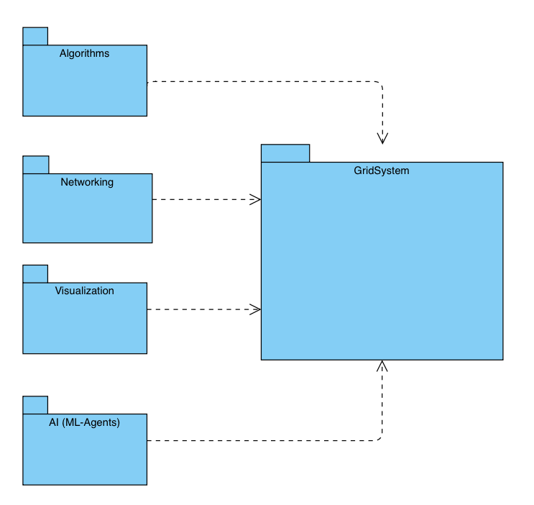

## Activity Diagram

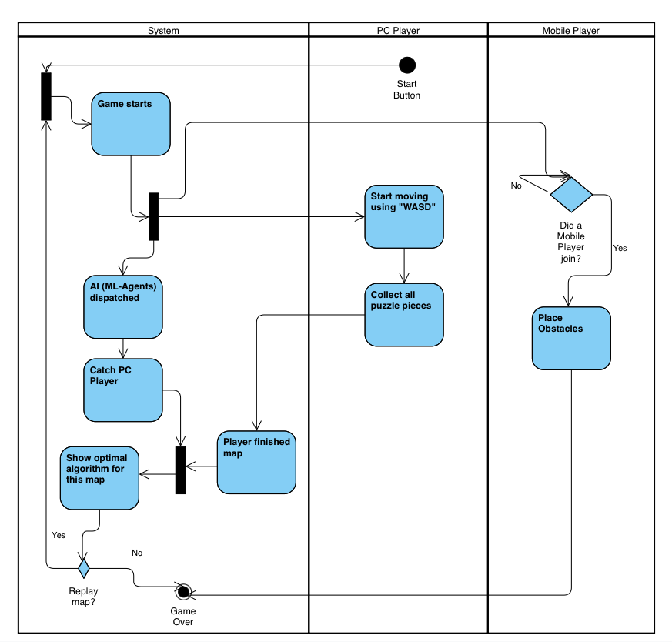

# Screens

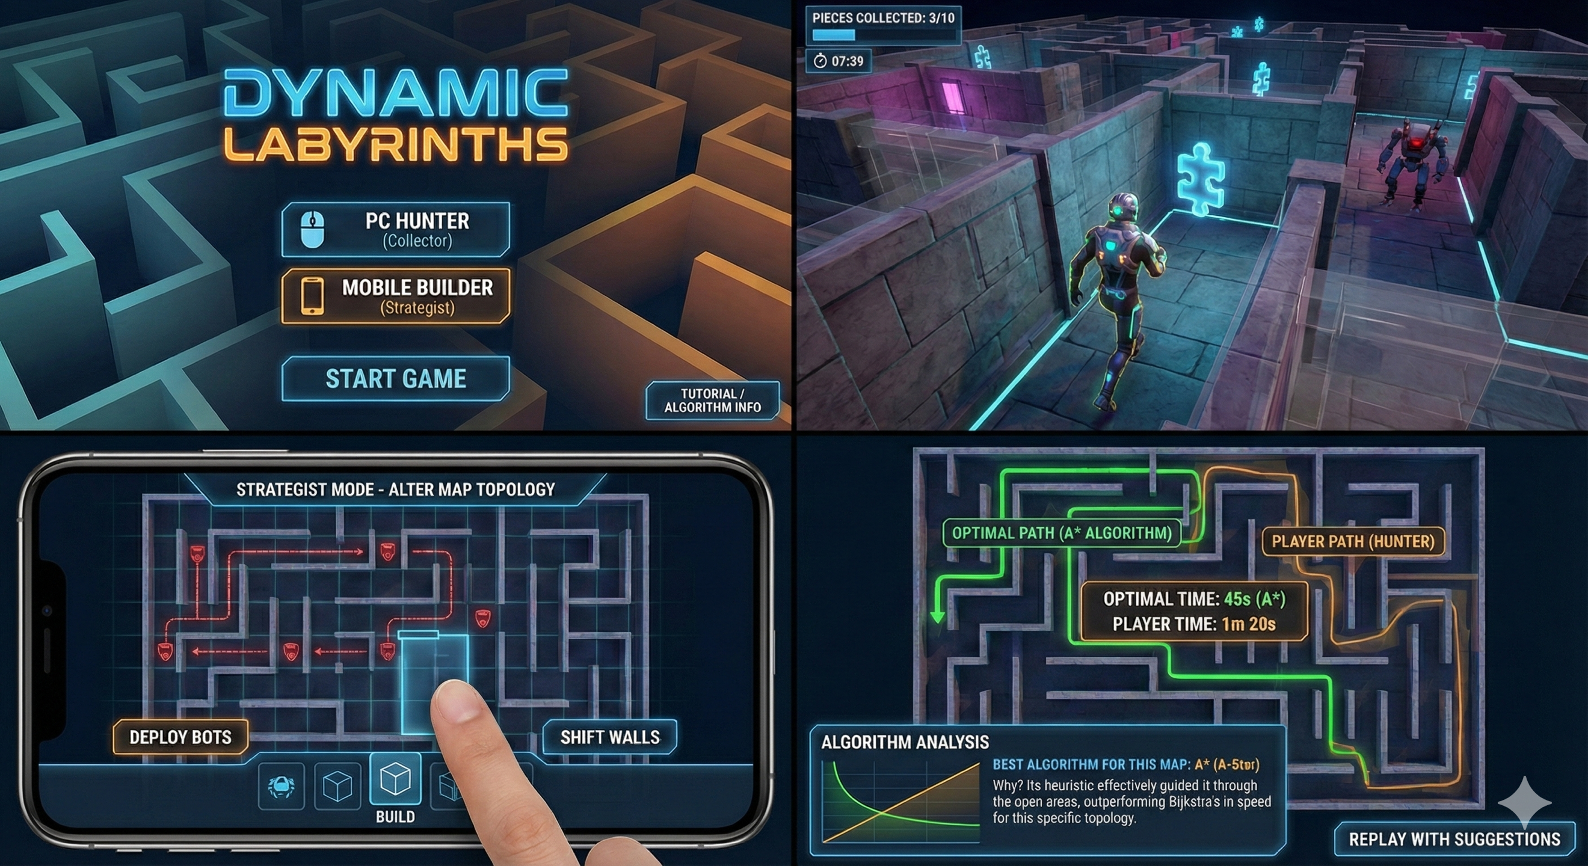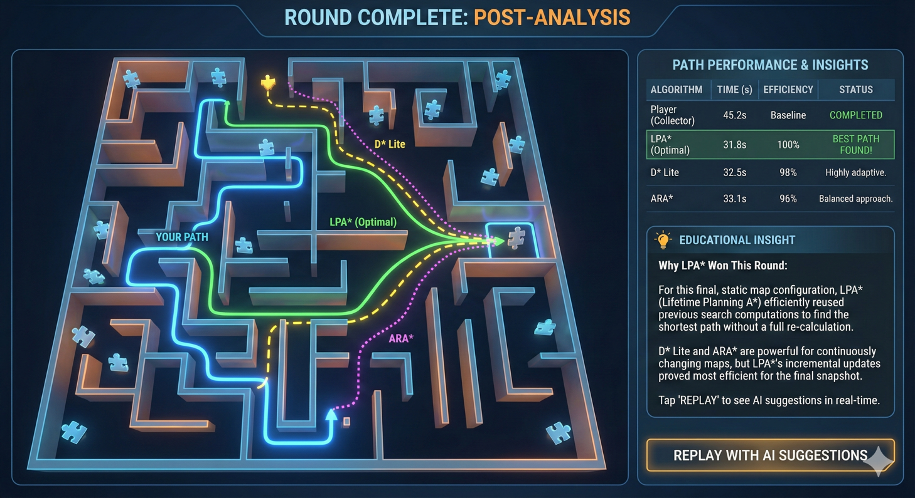

# Verification and Evaluation

## Evaluation

To ensure the system meets its functional requirements and achieves its educational objectives, we will employ a testing strategy divided into four key categories. Each category utilizes quantifiable measures to verify the project's success.

**Algorithmic Integrity & Mechanics Evaluation** This phase verifies the core computational logic of the system. We must ensure that the "gameplay", which in our case is the simulation of pathfinding, is mathematically accurate and responsive.

**System Performance & Network Evaluation** Since the project relies on cross-platform multiplayer, we must evaluate the technical stability of the connection between distinct hardware types.

**ML-Agent Proficiency Evaluation** This evaluation focuses on the intelligence and behavior of the Reinforcement Learning agent.

**User Experience & Educational Evaluation** Finally, we will assess the design's effectiveness in delivering educational concepts.

## Verification

To technically verify that our software meets the defined requirements, we will utilize the Unity Test Framework (UTF). This industry-standard tool allows us to write automated tests that run directly within the Unity Editor and on target devices, ensuring our code behaves exactly as expected.

We will aim to use three specific tools within this framework:

**EditMode Tests (Unit Testing for Algorithms)** These tests run instantly in the Unity Editor without needing to "play" the game. We will use them to verify Algorithmic Integrity.

**PlayMode Tests (Integration Testing)** These tests run the game loop in real-time, allowing us to verify Game Mechanics and Interaction.

**Performance Testing Extension (Benchmarking)** We will install the Unity Performance Testing package, which integrates with UTF to measure execution time and memory usage.

# References

1. **Boeker, M., Andel, P., Vach, W., & Frankenschmidt, A.** (2013). Game-based e-learning is more effective than a conventional instructional method: A randomized controlled trial with third-year medical students.
2. **Botea, A., Müller, M., & Schaeffer, J.** (2004). Near optimal hierarchical path-finding.
3. **Ding, Z., Huang, Y., Yuan, H., & Dong, H.** (2020). Introduction to reinforcement learning. In *Deep Reinforcement Learning: Fundamentals, Research and Applications*.
4. **El Naqa, I., & Murphy, M. J.** (2015). What is machine learning? In *Machine Learning in Radiation Oncology*.
5. **Gudadappanavar, A. M., Benni, J. M., & Javali, S. B.** (2021). Effectiveness of the game-based learning over traditional teaching-learning strategy to instruct pharmacology for Phase II medical students.
6. **Karaman, S., & Frazzoli, E.** (2010). Incremental sampling-based algorithms for optimal motion planning. *Robotics: Science and Systems.*
7. **Koenig, S., & Likhachev, M.** (2002). D* Lite. *Proceedings of the AAAI Conference on Artificial Intelligence.*
8. **Koenig, S., Likhachev, M., & Furcy, D.** (2004). Lifelong Planning A*. *Artificial Intelligence*.
9. **Korf, R. E.** (1988). Optimal path-finding algorithms. In L. Kanal et al. (Eds.), *Search in Artificial Intelligence*.
10. **Likhachev, M., Gordon, G. J., & Thrun, S.** (2003). ARA*: Anytime A* with provable bounds on sub-optimality. *Advances in Neural Information Processing Systems.*